

**Mechanical Workshop Project**

**(ES-Me-292)**

**Dual Axis Solar tracker**

**B.Tech 1st Year Sec I**

**Group 2**

**Date of Submission:**

**29/04/2019Group Members**

**Roll no. Name**

17 Bidisha Misra

18 Debamita Pal

19 Dwijo Ganguly

20 Farhan Hai Khan

21 Hadeeqa Nishat

22 Himanshu Tripathi

23 Koushan De

24 Madhurima Mukherjee

25 Md. Nasir

26 Md. Nadeem Akhter

27 Neha Talukder

28 Nilanjana Bandyopadhyay

29 Nirmalya Ganguli

30 Prajata Samanta

31 Pranab Maity

32 Prashant Gourav

33 Prateek Majumder

42 Sandeep Saurav

Model: **Dual Axis Solar Tracker**

**Abstract**

Solar panels have been used increasingly in recent years to convert solar energy to electrical energy. The solar panel can be used either as a stand-alone system or as a large system that is connected to the electricity grid. The earth receives 84 Terawatts of power and our world consumes about 12 Terawatts of power every day. We are trying to extract more energy from the sun using solar panels. In order to maximize the conversion from solar to electrical energy, the solar panels have to be positioned perpendicular to the sun. Thus the tracking of the sun’s location and positioning of the solar panel are important. The goal of this project is to design an automatic tracking system, which can locate the position of the sun. The tracking system will align the solar panel so that it is positioned perpendicular to the sun for maximum energy conversion at all times. Photo-resistors will be used as sensors in this system. The system will consist of light sensing devices, microcontroller, gear motor system, and a solar panel. LDRs shall be used as the main light sensors. Two servo motors are to be fixed to the structure that holds the solar panel. The program for Arduino is to be uploaded to the microcontroller. LDRs sense the amount of sunlight falling on them. Four LDRs are divided into top, bottom, left and right. For east – west tracking, the analog values from two top LDRs and two bottom LDRs are compared and if the top set of LDRs receive more light, the vertical servo will move in that direction. If the bottom LDRs receive more light, the servo moves in that direction.

For angular deflection of the solar panel, the analog values from two left LDRs and two right LDRs are compared. If the left set of LDRs receive more light than the right set, the horizontal servo will move in that direction. If the right set of LDRs receive more light, the servo moves in that direction. Our system will provide an output with up to 40% more energy than the solar panels without tracking systems. The generation of power without using fossil fuels is the biggest challenge for the next half of this century. The idea of converting solar energy into electrical energy using photovoltaic panels holds its place in the front row as compared to other renewable sources. However the continuous change in the relative angle of the sun with reference to the earth reduces the watts delivered by the solar panel. In this context solar tracking system is the best alternative to increase the efficiency of the photovoltaic panel. Solar trackers move the payload towards the sun throughout the day.

**Components Required**

Estimated cost(in Rs.)

* Arduino UNO  - 400
* Servo Motors - 150*2
* Breadboard- 100
* LDR  - 10*4
* Resistors (100 K-ohm)- 50

Total estimated cost:- **Rs.1000(approx)**

**Time Estimation**

Milestones for the project:

1st week: Gathering of information and knowledge build-up.

2nd week: Collection of the components required

3rd week: Assembling the necessary parts

4th week: Coding the Arduino

5th week: Calibration and testing of the constructed model.

Total estimated time: **5 weeks**

**The Circuit Diagram**

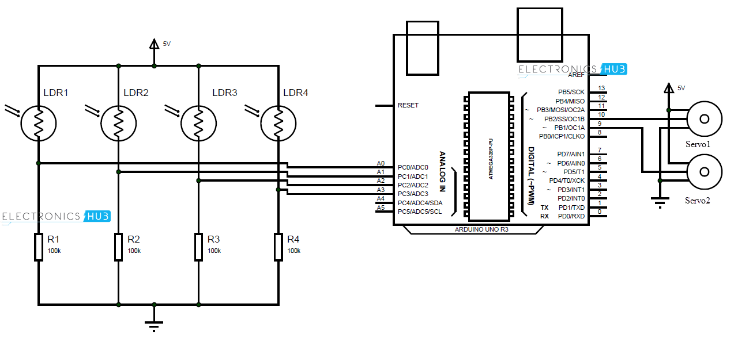

**Fig 1.**

**The Source Code**

//code created by CrazyCoderz INC

//last modified : 5th May 2019

//author?khanfarhan10

//crazycoderz6.webnode.com

//header files

#include<Servo.h> // include Servo library for controlling the servo motor

//standard variables used

// 180 horizontal MAX

Servo horizontal; // horizontal servo

int servoh = 180; // 90; // stand horizontal servo

//limiting variables for horizontal rotation

int servohLimitHigh = 180;

int servohLimitLow = 65;

// 65 degrees MAX

Servo vertical; // vertical servo

int servov = 45; // 90; // stand vertical servo

//limiting variables for vertical rotation

int servovLimitHigh = 80;

int servovLimitLow = 15;

// LDR pin connections

// name = analogpin;

int ldrlt = 0; //LDR top left - BOTTOM LEFT

int ldrrt = 1; //LDR top right - BOTTOM RIGHT

int ldrld = 2; //LDR down left - TOP LEFT

int ldrrd = 3; //LDR down right - TOP RIGHT

void setup()

{ Serial.begin(9600);

// servo connections

// name.attach(pin);

horizontal.attach(9);

vertical.attach(10);

horizontal.write(180);

vertical.write(45);

delay(3000);

}

void loop()?

{ int lt = analogRead(ldrlt); // top left

int rt = analogRead(ldrrt); // top right

int ld = analogRead(ldrld); // down left

int rd = analogRead(ldrrd); // down right

// int dtime = analogRead(4)/20; // read potentiometers

// int tol = analogRead(5)/4;

int dtime = 10; int tol = 50;

int avt = (lt + rt) / 2; // average value top

int avd = (ld + rd) / 2; // average value down

int avl = (lt + ld) / 2; // average value left

int avr = (rt + rd) / 2; // average value right

int dvert = avt - avd; // check the difference of top and down

int dhoriz = avl - avr;// check the diffirence of left and right

Serial.print(avt);

Serial.print(" ");

Serial.print(avd);

Serial.print(" ");

Serial.print(avl);

Serial.print(" ");

Serial.print(avr);

Serial.print(" ");

Serial.print(dtime);

Serial.print(" ");

Serial.print(tol);

Serial.println(" ");

if (-1*tol > dvert || dvert > tol) // check if the difference is in the tolerance else change vertical angle

{

if (avt > avd) //average top Greater than average down

{

servov = ++servov; //increas vertical by 1 degree

if (servov > servovLimitHigh) //average vertical Greater than the prescribed max limit of vertical rotation

{

servov = servovLimitHigh; //assign max limit

}

}

else if (avt < avd) //average shifts downwards then decrease servo vertical angle

{

servov= --servov;

if (servov < servovLimitLow)

{

servov = servovLimitLow;

}

}

vertical.write(servov);

}

if (-1*tol > dhoriz || dhoriz > tol) // check if the difference is in the tolerance range else change horizontal angle

{

if (avl > avr)

{

servoh = --servoh;

if (servoh < servohLimitLow)

{

servoh = servohLimitLow;

}

}

else if (avl < avr)

{

servoh = ++servoh;

if (servoh > servohLimitHigh)

{

servoh = servohLimitHigh;

}

}

else if (avl = avr)

{

// nothing

}

horizontal.write(servoh);

}

delay(dtime);

}

**Procedure**

1. As per the list of components four LDRs were taken and one of their ends were soldered onto a vero board in such a manner so that the four LDRs are placed in square fashion.
2. A partition was made using two copper strips at the centre of the four LDRs so that light doesn’t fall evenly on all the LDRs simultaneously.
3. After soldering one of the pins of the LDRs onto the vero board the other pin was joined and soldered in common with one end of a 10K ohm resistor. This was done similarly for all the four LDRs.
4. The other end of the resistors was also soldered to the vero board.
5. A ten pin port was fixed to the vero board at one side so as to form the interface between the vero and the other peripherals such as the microcontroller, etc.
6. Two servo motors were mechanically attached using perforated aluminum plates so that one of the servos serves as the vertical axis and the other as the horizontal axis.
7. After the above steps the circuit connections were made using the microcontroller, i.e Arduino Uno R3 as per the given circuit diagram in fig 1.
8. The servo motors and the vero board were powered separately from the Arduino with the help of a breadboard.

**Future Prospects**

As already mentioned earlier, a dual-axis solar tracker is much more efficient than a normal solar panel fixed at the same position all throughout the day since it can change its orientation depending upon the direction of the incident sunlight. The idea of a solar tracker can be well implemented in a country like India situated in the tropical region and thereby receiving most of the sunlight. Being able to rotate and change its position a solar tracker can provide maximum efficiency that can be achieved by a solar panel. We can overcome the problems of the thermal power through solar energy which is freely available at least for the next one million years. Therefore if we can properly utilize solar energy then the capability of generation centers might shoot up to such high levels that energy consumption in terms of electricity might get cheaper. However, maintenance is a crucial factor with respect to the installation of solar panels but still it is a way better alternative than burning our non-renewable sources of energy.